**n**

**-n**

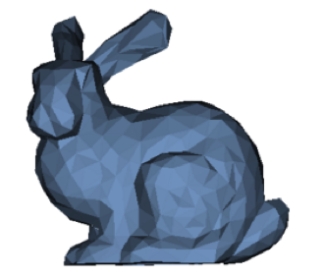

The original object with a normal vector for the top face. The angle between **p** and **n** is 90 degrees.

The object transformed vertically with non-uniform scaling. The angle between **p’** and **n’** must be 90 degrees.

**n**

**p**

**n’**

**p’**

The original object with the normal vectors for the top two faces.

The object transformed vertically with non-uniform scaling. Notice that the original normal vectors are skewed. The desired normal vectors are shown in orange.

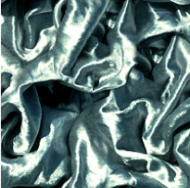

A 256x256 image

Two copies of the image side by side. Notice that the left and right edge match seamlessly.



fragment location

in bump map

map(s+1,t) = 134

map(s-1,t) = 127

map(s,t-1) = 89

map(s,t+1) = 101